**Final Project Report**

Data Mining

-Tingjian Ge

Submitted by

-Shaili Trivedi(Shaili_Trivedi@student.uml.edu)

Student Id : 02008856

**Abstract :** We have been asked to create a simple neural network model to predict whether a particular mushroom that we have is poisonous or edible using agaricus-lepiota.data. The data given has in total 23 feature through which we can identify if the mushroom is edible or not.

**Screenshot of the report with some of the partial Running results**

Screenshot : 1 (data_con.py)

Screenshot 2 : (proj_test.py)

Screenshot 3 : (proj_test.py)

Screenshot 4 : (proj_test.py)

Screenshot 5 : (proj_test.py)

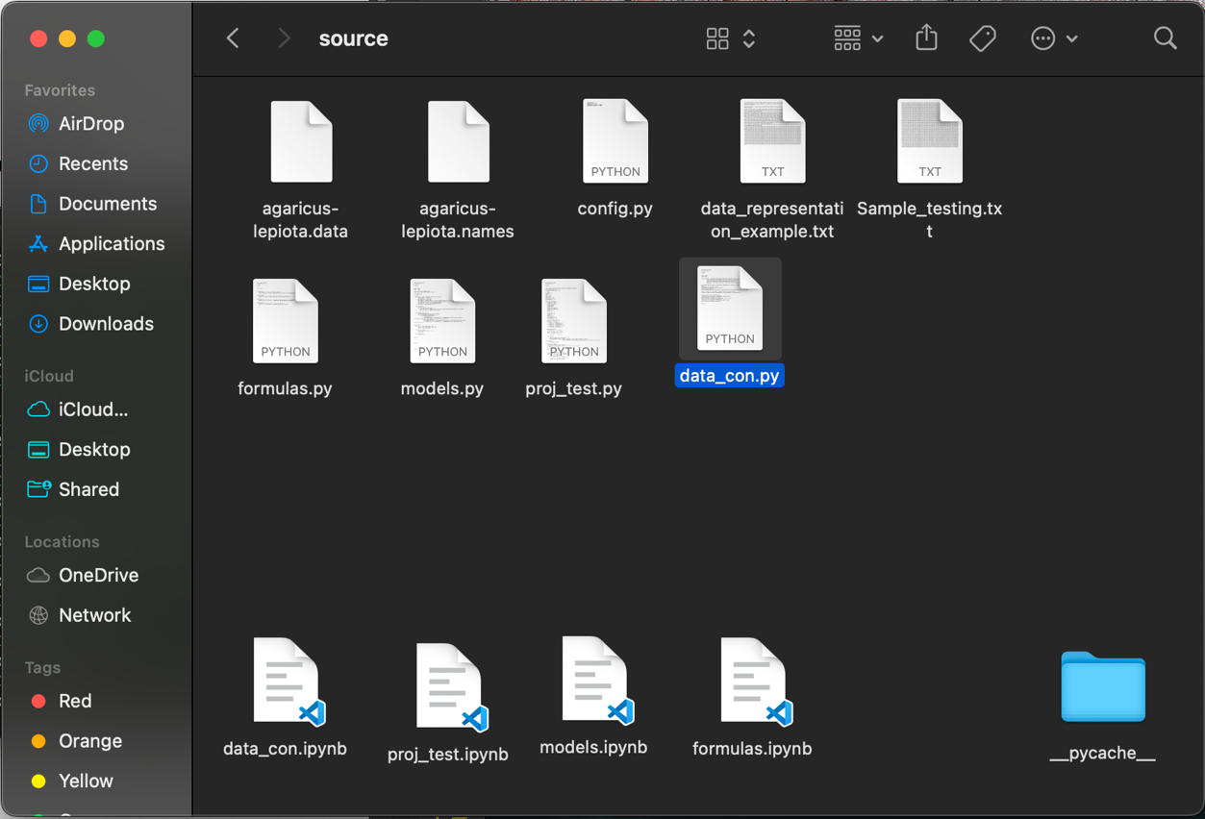

Screenshot 5 : Basic Files

Screenshot 6 : Folder with training.txt,validation.txt and testing.txt

Screenshot 7 : Folder with training_err.txt, validation.txt and testing_err.txt

**Conclusion**: Successfully created model that can predict weather the mushroom is edible or poisonous.